Reduction of Flexural Crack Widths Using Synthetic Fibres in Reinforced Concrete

Erik Stefan Bernard¹

¹: Technologies in Structural Engineering Pty Ltd, Sydney, Australia.

Abstract
The use of steel fibres to reduce the width of flexural and tensile cracks in reinforced concrete members is now well recognised and aspects of this phenomenon have been incorporated into several codes internationally. Almost all the research work upon which this has been based has involved hooked-end steel fibres, with very little work undertaken using other types of fibre. However, the theories underlying how fibres assist in reducing crack widths are not specific to hooked-end steel fibres, so alternative types of fibre could work in a similar way to reduce crack widths in flexural and tensile members.
The current paper outlines work recently completed on the effect of several types of synthetic fibre on flexural crack widths in reinforced concrete members. The fibres have predominantly been manufactured using polypropylene, but other materials including aramide, nylon and PVA can also be used for this purpose and have been included in this investigation. Laboratory testing has demonstrated that synthetic fibres are fully capable of reducing flexural crack widths, but their efficacy is not consistent across all fibre types and designs. Testing appears to demonstrate that for a given dosage rate of fibre, the capacity of a FRC mix to limit flexural crack widths is related to the post-crack residual strength. However, some fibres can limit crack widths more effectively than is predicted by existing expressions for design width that are based primarily on post-crack residual strength. This suggests that post-crack toughness is not the only parameter contributing to crack width reduction in Reinforced Concrete members.

Keywords
Crack width, fibre reinforced concrete, post-crack performance, flexure, tension stiffening, conventional reinforcement

Introduction
Flexural and tensile cracks can lead to corrosion of reinforcement in conventionally reinforced concrete (RC) members, so limits are normally placed on maximum in-service crack widths to reduce the probability of corrosion during the anticipated design life. Numerous investigations have been undertaken examining the possibility of using steel fibres to reduce crack widths in conventionally reinforced members and these have demonstrated that steel fibres are effective for this purpose (Vandewalle, 2000; Duport and Vanderwalle, 2003; Jansson et al, 2010; Deluce et al, 2014). Theories developed to explain the mechanism by which steel fibres reduce crack widths in reinforced concrete flexural members do not explicitly depend on the composition of the fibres but instead rely on the tensile stress generated by the fibres across cracks to reduce the spacing between cracks and thus crack widths (Abrishami and Mitchell, 1997; Bischoff, 2003). Since it is known that synthetic fibres are capable of generating substantial post-crack tensile stress, it is therefore possible that synthetic fibres may also be capable of reducing crack widths in reinforced concrete flexural members. This was demonstrated by Bernard (2016) for one type of embossed polypropylene macro-synthetic fibre, and Conforti et al (2018) for synthetic and glass fibres, but little work has otherwise addressed this issue.
The contribution of steel fibres to reduced flexural crack widths in RC flexural members has been recognized in guidelines such as Model Code 2010. Nearly all the research undertaken in relation to crack width reduction has used hooked-end steel fibres. While this prior work has established the concept that fibres can contribute to reduced flexural crack widths, the resulting expressions are specific to hooked-end steel fibres and are not necessarily applicable to other types of fibre. The current investigation was undertaken to examine whether alternative fibre types can also be used for this purpose.
In the present work, crack width estimates have been limited to the Serviceability Limit State at which the stress in the reinforcing bars is relatively moderate. This has nominally been taken to be 50 percent of the ultimate load capacity of a member. For ease of comparison, all the fibres examined in this investigation have been tested using an identical RC member configuration and the same nominal mix design for the concrete. While this has facilitated comparison of fibre performance, use of a single conventional reinforcement configuration has meant that identifying the full range of performance characteristics for each type of fibre in this application is not possible. In particular, many of the fibres may possibly perform better (or worse) using a different concrete mix design.

Experimental program
The experimental component of the investigation consisted of a series of trials in which 3600 mm long beams of 300×300 mm cross-section were cast using either plain concrete (as the control) or the same mixture reinforced with various types of fibre. The mix design for the concrete was the same for all the trials, and is listed in Table 1. The fibre types and mixture performance details are listed in Table 2. Conventional steel reinforcement comprising 3×16 mm deformed steel bars of 500 MPa nominal tensile strength and normal ductility (AS/NZS 4671) were placed with 30 mm clearance from the base. The specimens did not include any stirrups or compression steel as it was believed that inclusion of stirrups may influence the spacing between flexural cracks. Preliminary tests showed that shear failure did not occur for this configuration. Four replicate RC beams were cast for each trial together with seven ASTM C1609/C1609M beams for post-crack performance assessment.
The fibres examined in the investigation included Dramix RC65/60 3D hooked-end steel fibres acting as a SFRC control (Table 2). Three macro-synthetic fibre types were included, BC48 as an embossed polypropylene (PP) fibre, MQ58 as an embossed polymer blend fibre, and Fibermesh 650 as a smooth tape PP fibre. Fibermesh 150 is a smooth circular micro-synthetic PP fibre. Of the remaining fibres, all were circular in cross-section and smooth except for the aramide fibre which had a rectangular cross-section and was partially twisted. Both the glass and basalt fibres were initially bundled but fragmented during mixing to produce dispersed micro fibres that were finely distributed throughout the mixture.
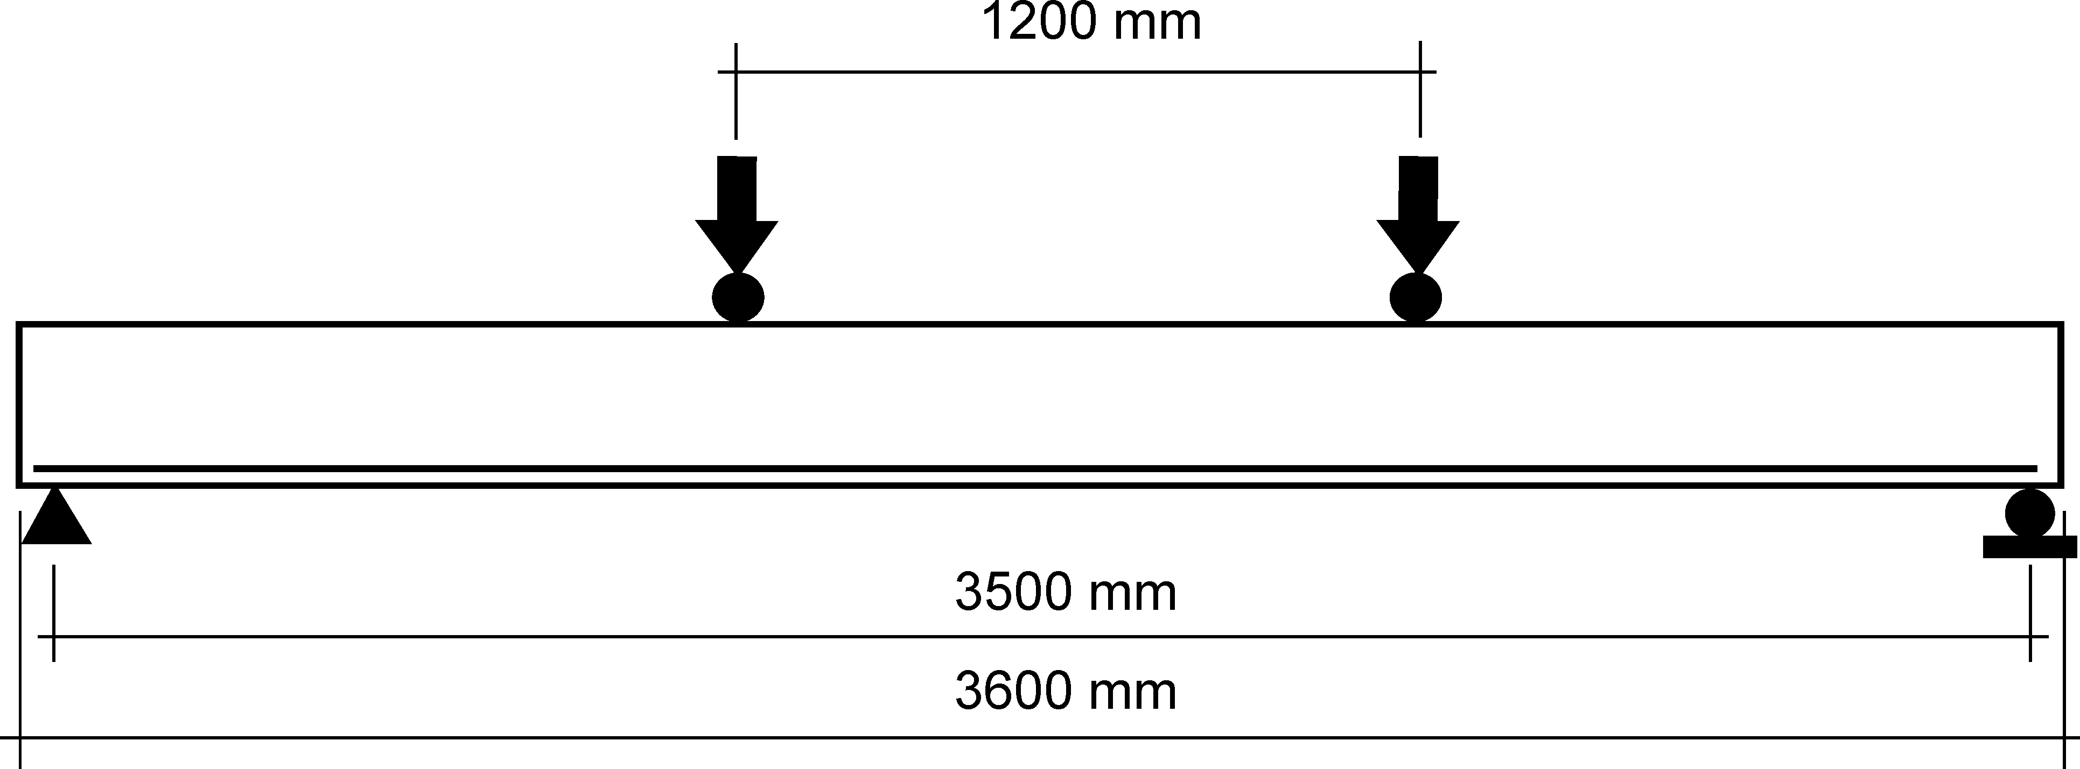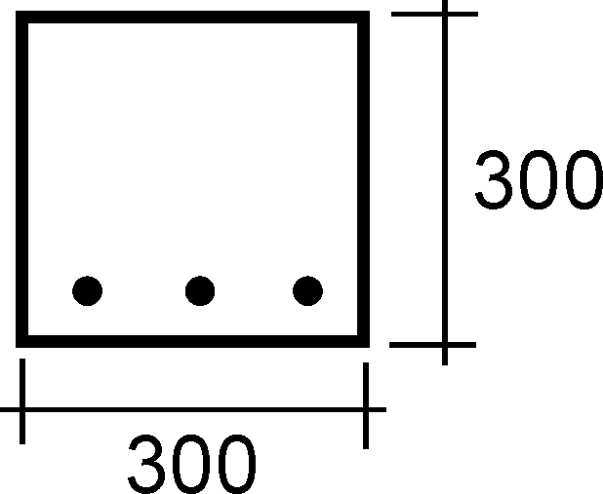
(a) | (b)
Figure 1: (a) Two-point lateral loading on each beam specimen, and (b) cross-section
The concrete used in the trials was produced in a commercial dry-batch plant with the 1.5 m³ load required for each specimen set delivered to the laboratory in a truck-mounted agitator. Fibres were added to the batch at the lab, and about 500 mL/m³ of PCE superplasticizer was required to maintain acceptable workability for each of the micro-synthetic FRC loads.
Table 1: Mix design for 32 MPa cast concrete mix used in all trials.
Ingredient | Quantity (kg/m³)
10 mm CRG | 1000
Coarse sand | 460
Fine sand | 250
GP cement | 280
Fly ash | 100
LR Water reducer | 1330 mL/m³
Target slump | 150 mm

All of the beams were tested using essentially the same procedure. The beams were placed upon two roller supports on a span of 3500 mm and subjected to two equal point loads, each a distance of 1150 mm from the adjacent support (thus the central span was 1200 mm, Fig. 1). Load was applied using a 250 kN servo-controlled actuator operating in stroke-control. The initial central displacement of the beam was 3.0 mm loaded at a rate of 2 mm/min. The displacement was then stopped and the beam inspected for cracks. In some cases initial flexural cracks had occurred, in others there were no signs of flexural cracking. Load was then increased in increments of 1.5 mm displacement applied at a rate of 2.0 mm/min followed by pauses to permit crack widths to be manually measured using a 100× optical field microscope. Each pause lasted approximately 5 minutes during which the stroke was held constant and crack widths were measured resulting in a series of steps in the record (Fig. 2a). This cycle of loading and holding the displacement continued for about 60-80 minutes until a total central displacement of about 25-30 mm had been sustained, by which time yielding of the tensile bars had occurred. Approximately 12-15 sets of crack width measurements, and corresponding loads, were recorded for each beam. The central deflection of the beam was measured relative to the supports using an LVDT placed under the centre of the beam.
Table 2: Test series and fibre characteristics for all the sets of specimens tested.
Set | Reinforcement | Type | Dosage  (kg/m³) | V_{f}  (%) | UCS  (MPa) | f_{t}  (MPa) | f_{0.75}  (MPa)
1 | Plain Concrete | - | - | - | 44 | 6.14 | 0.00
2 | RC65/60 3D | 60 mm hook-end steel | 20 | 0.25 | 48 | 7.44 | 2.87
3 | BC48 | 48 mm embossed PP | 4.5 | 0.50 | 43 | 6.68 | 2.47
4 | MQ58 | 58 mm embossed poly | 4 | 0.44 | 43 | 6.26 | 1.44
5 | Aramide | 1 × 30 mm twisted | 4 | 0.30 | 45 | 5.89 | 2.49
6 | Fibermesh 650S | 60 mm tape PP | 4.5 | 0.50 | 42 | 6.68 | 1.16
7 | Fibermesh 150 | ∅32 μm micro-syn. PP | 4 | 0.44 | 41 | 6.17 | 0.37
8 | PA | ∅135 μm 12 mm Nylon | 4 | 0.42 | 47 | 6.31 | 0.36
9 | Glass | ∅30 μm 18 mm glass | 4 | 0.16 | 42 | 6.23 | 0.00
10 | Basalt | ∅30 μm 20 mm basalt | 4 | 0.12 | 46 | 5.79 | 0.00
11 | PVA | ∅26 μm 6 mm PVA | 4 | 0.31 | 45 | 6.25 | 0.30

Crack widths were always measured on the side of the beam at a distance of 10 mm from the bottom face. This was necessary because the edges of the beams were quite rough which did not permit accurate estimation of crack widths. At about 50% of ultimate moment capacity (70 kN total load) the distance between each crack was measured using a steel rule on both sides of the beam. In most of the tests additional cracks arose as load increased, resulting in a steady decrease in the mean crack spacing. However, for the purposes of design, only those cracks that were present at the service load (presently taken to be 70 kN, or 40.2 kNm moment) are of interest to estimates of mean and maximum crack spacing. Only those cracks occurring in the region of uniform bending moment between the two load points were assessed in this investigation.

Test Results
Each series of four beams was tested at the same age of about 4 months, using the same testing procedure, leading to the generation of load-deflection curves of the type shown in Fig. 2a, ASTM C1609 beam results (eg. Fig. 2b), and records of mean crack width (Fig. 3). The plain concrete specimens were taken as controls against which mean crack spacing and widths for all the other sets were compared. The data show that almost all of the fibre configurations examined in this investigation caused the mean crack width to decrease, with the glass fibres proving the least effective and the PVA fibres the most effective. A substantial difference in mean crack spacing often occurred between nominally identical specimens (Fig. 4). This occurred because the number of flexural cracks in the central 1200 mm region of uniform bending moment was not the same for all four beams within a set. It required a difference in crack count of only 1-2 to result in a substantially different mean crack spacing. This occurred, for example, for the BC48, MQ58, and PVA reinforced beam sets.
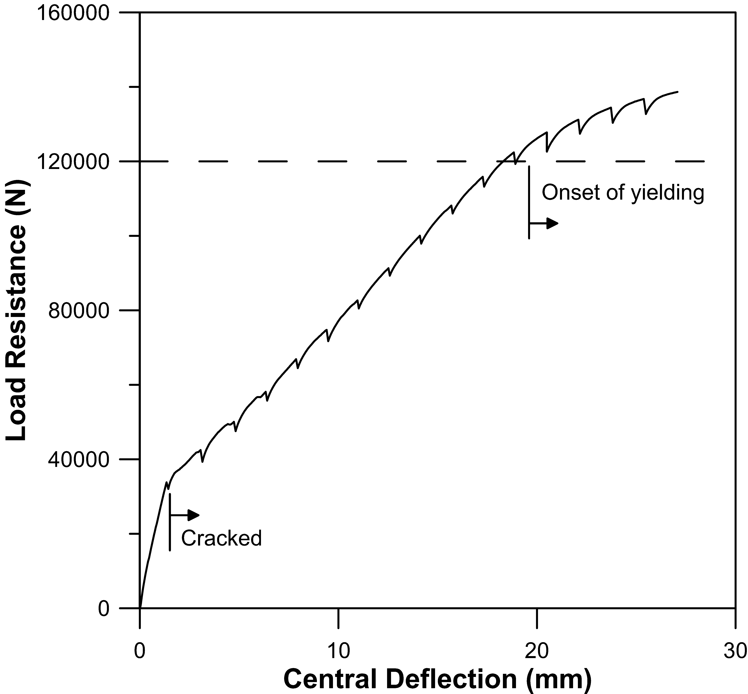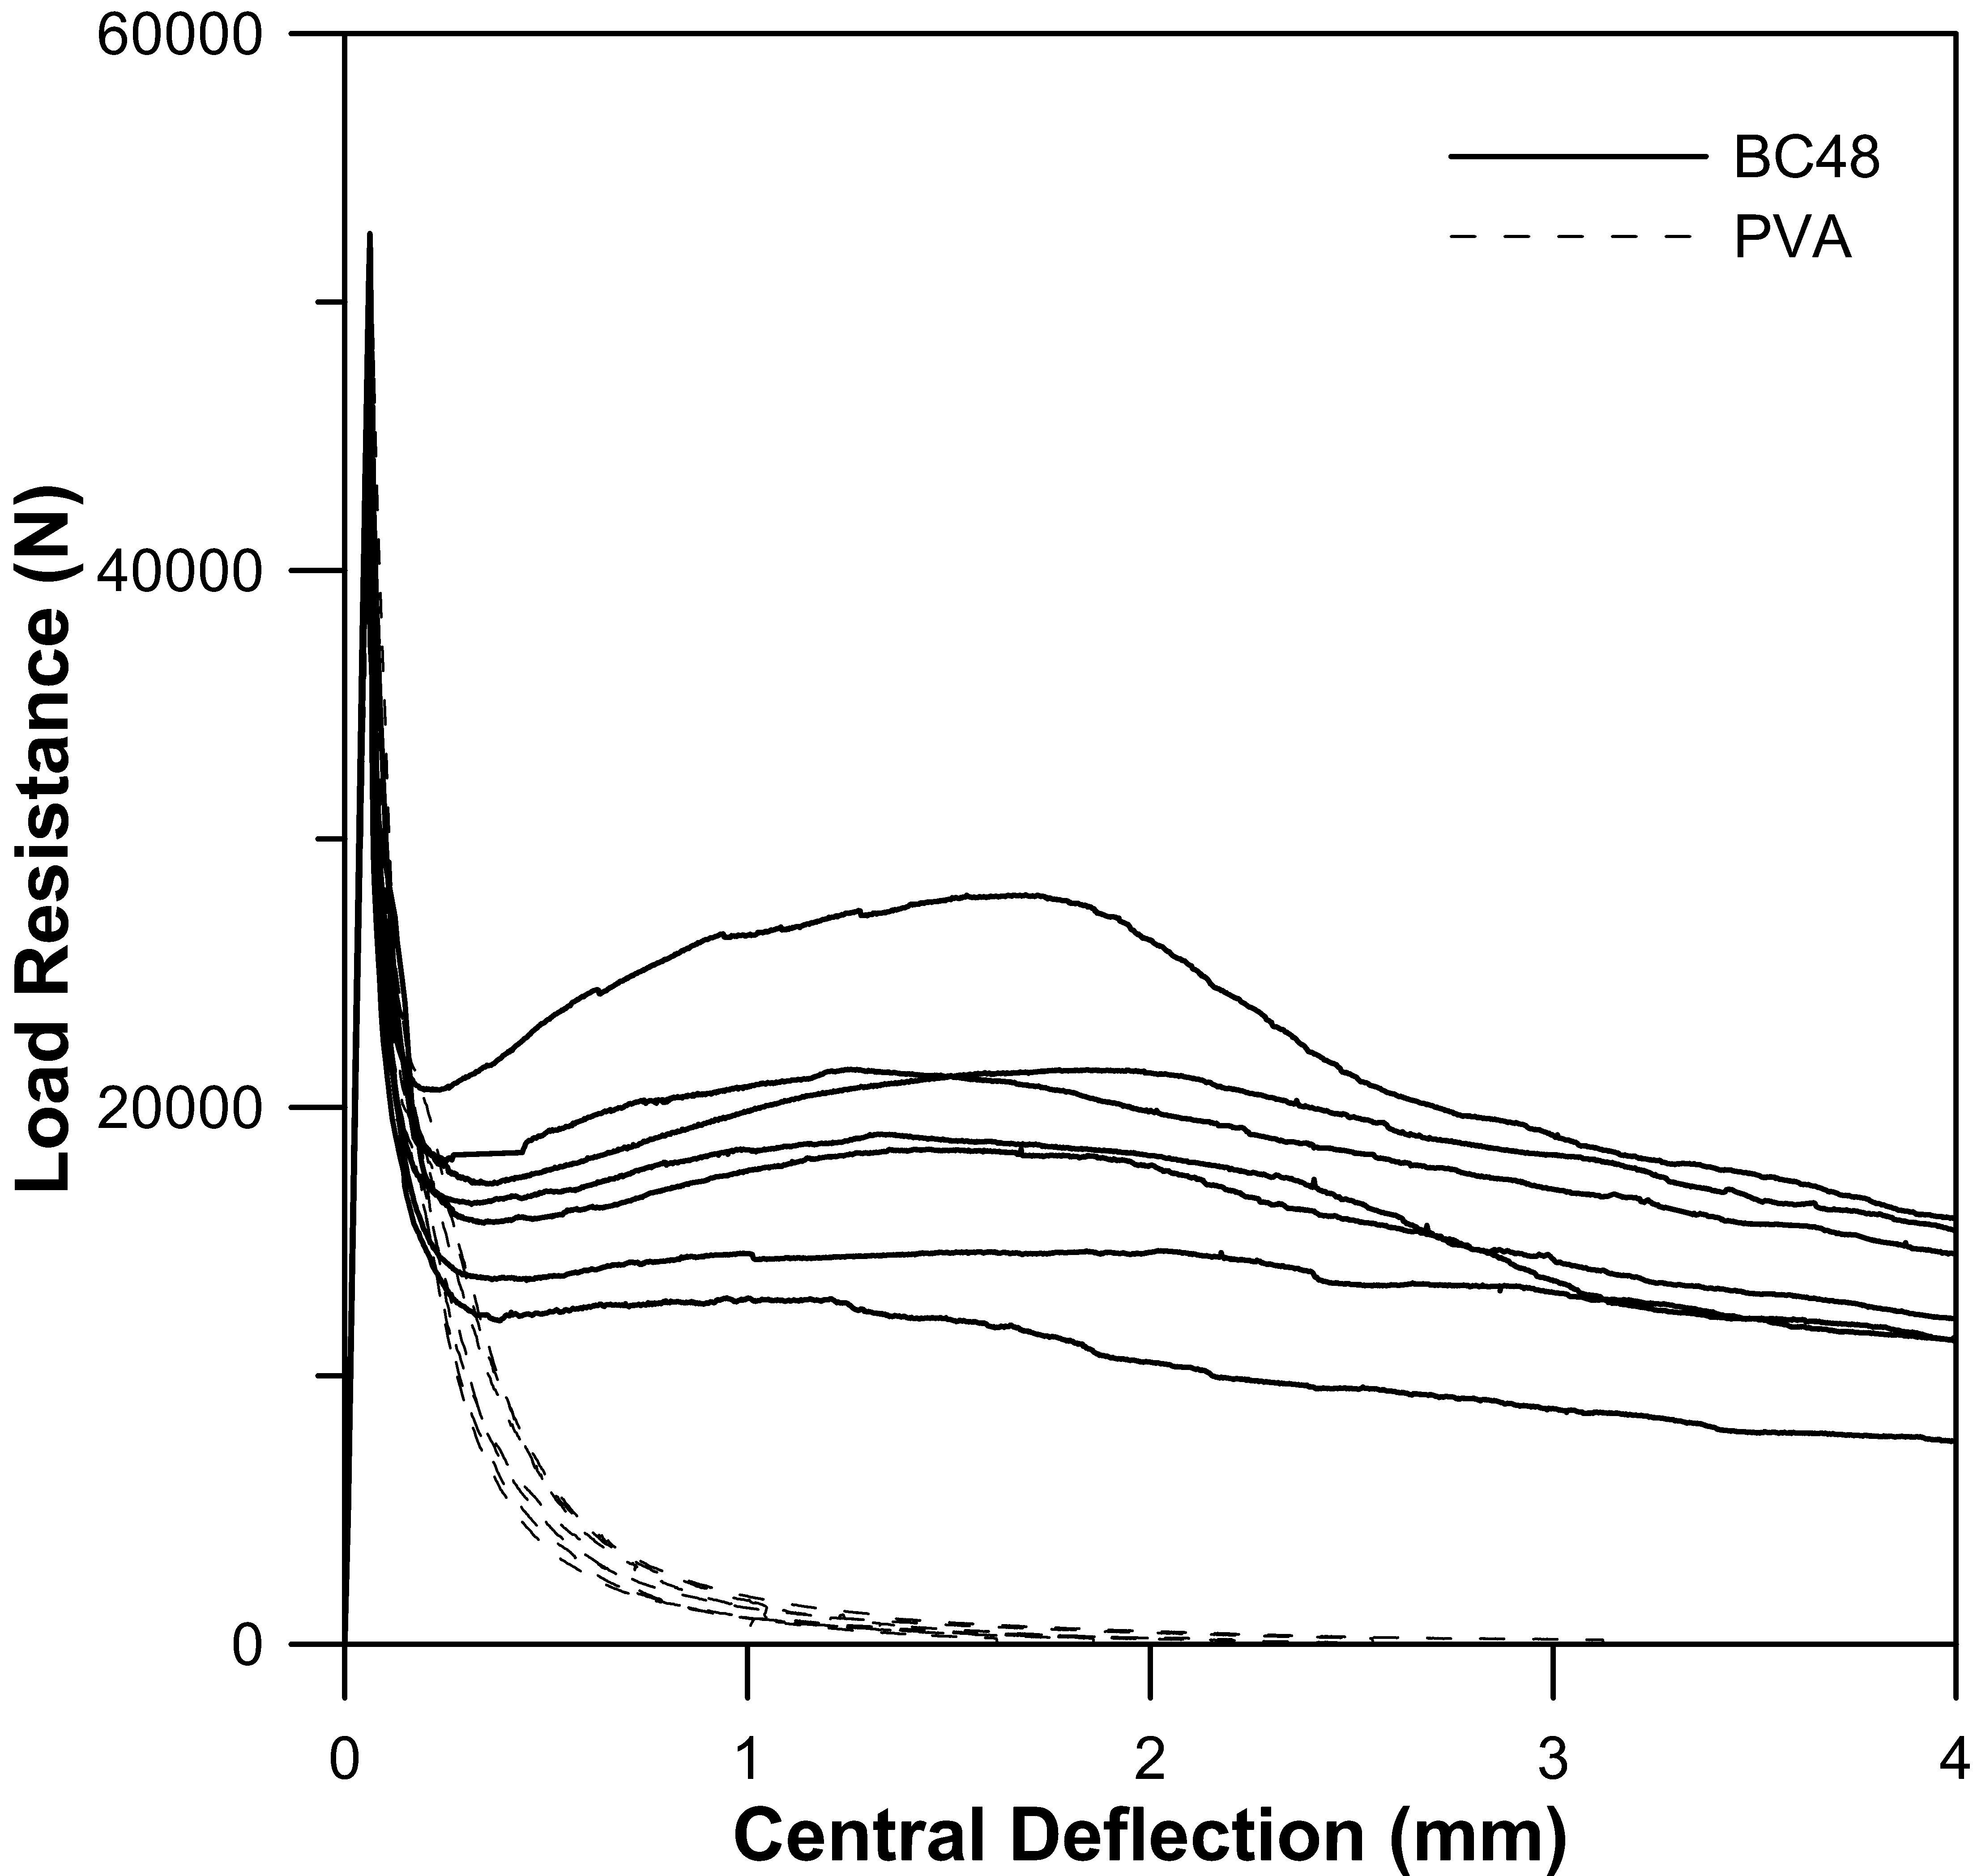
(a) | (b)
Figure 2: Example (a) load-deflection curve for beam with aramide fibres, (b) ASTM C1609 results.
The mean crack width results help to differentiate fibre types that show promise in reducing flexural crack widths from those that do not (Fig. 5). The Fibremesh 150 micro-synthetic fibres not only proved very difficult to consolidate at a dosage rate of 4 kg/m³, but also proved ineffective for reducing crack widths. The PA (Nylon) fibres were less onerous in terms of mixability, but also proved ineffective for crack width reduction. The glass and basalt-based micro fibres were similarly unable to reduce crack widths compared to the plain concrete control. All the macro-synthetic fibres produced a similar reduction in crack width (with adjustment for dosage, given that the BC48 and FM650S were dosed at 4.5 kg/m³ while the MQ58 and aramide fibres were dosed at 4 kg/m³) and appeared comparable to the Dramix RC65/60 3D steel fibres at 20 kg/m³ in terms of effectiveness at a moderate dosage rate.
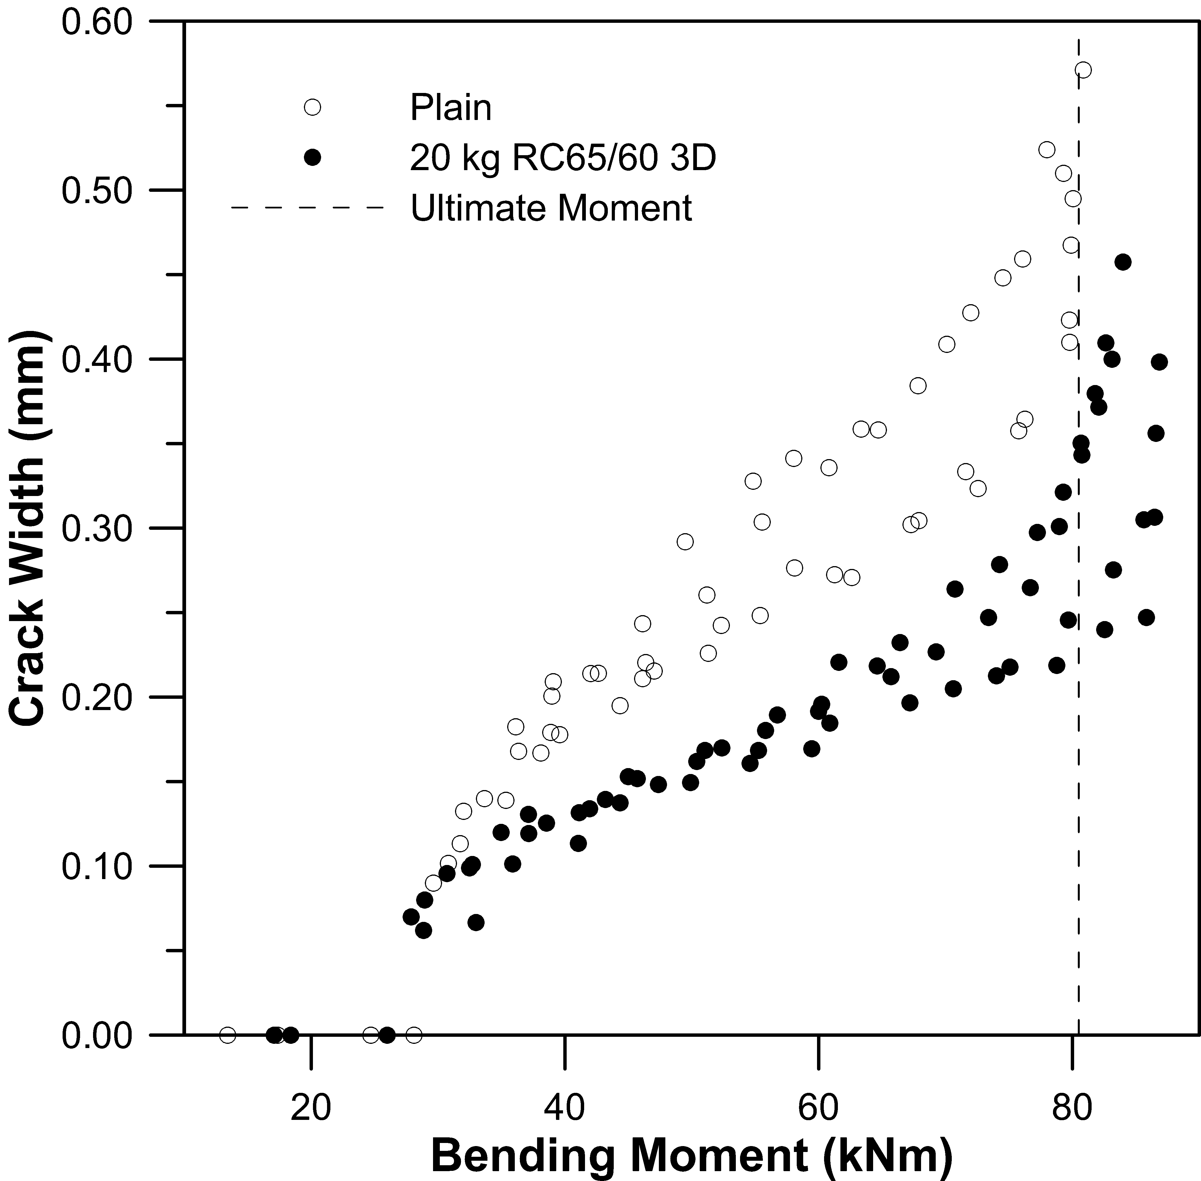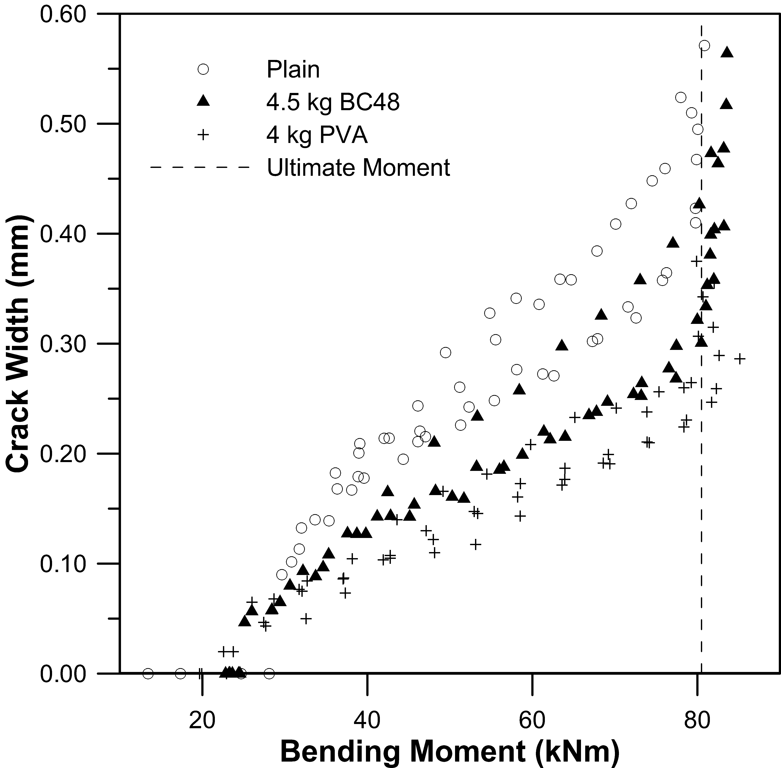
(a) | (b)
Figure 3: Crack width development for, (a) plain and RC65/60, and (b) BC48 and PVA.
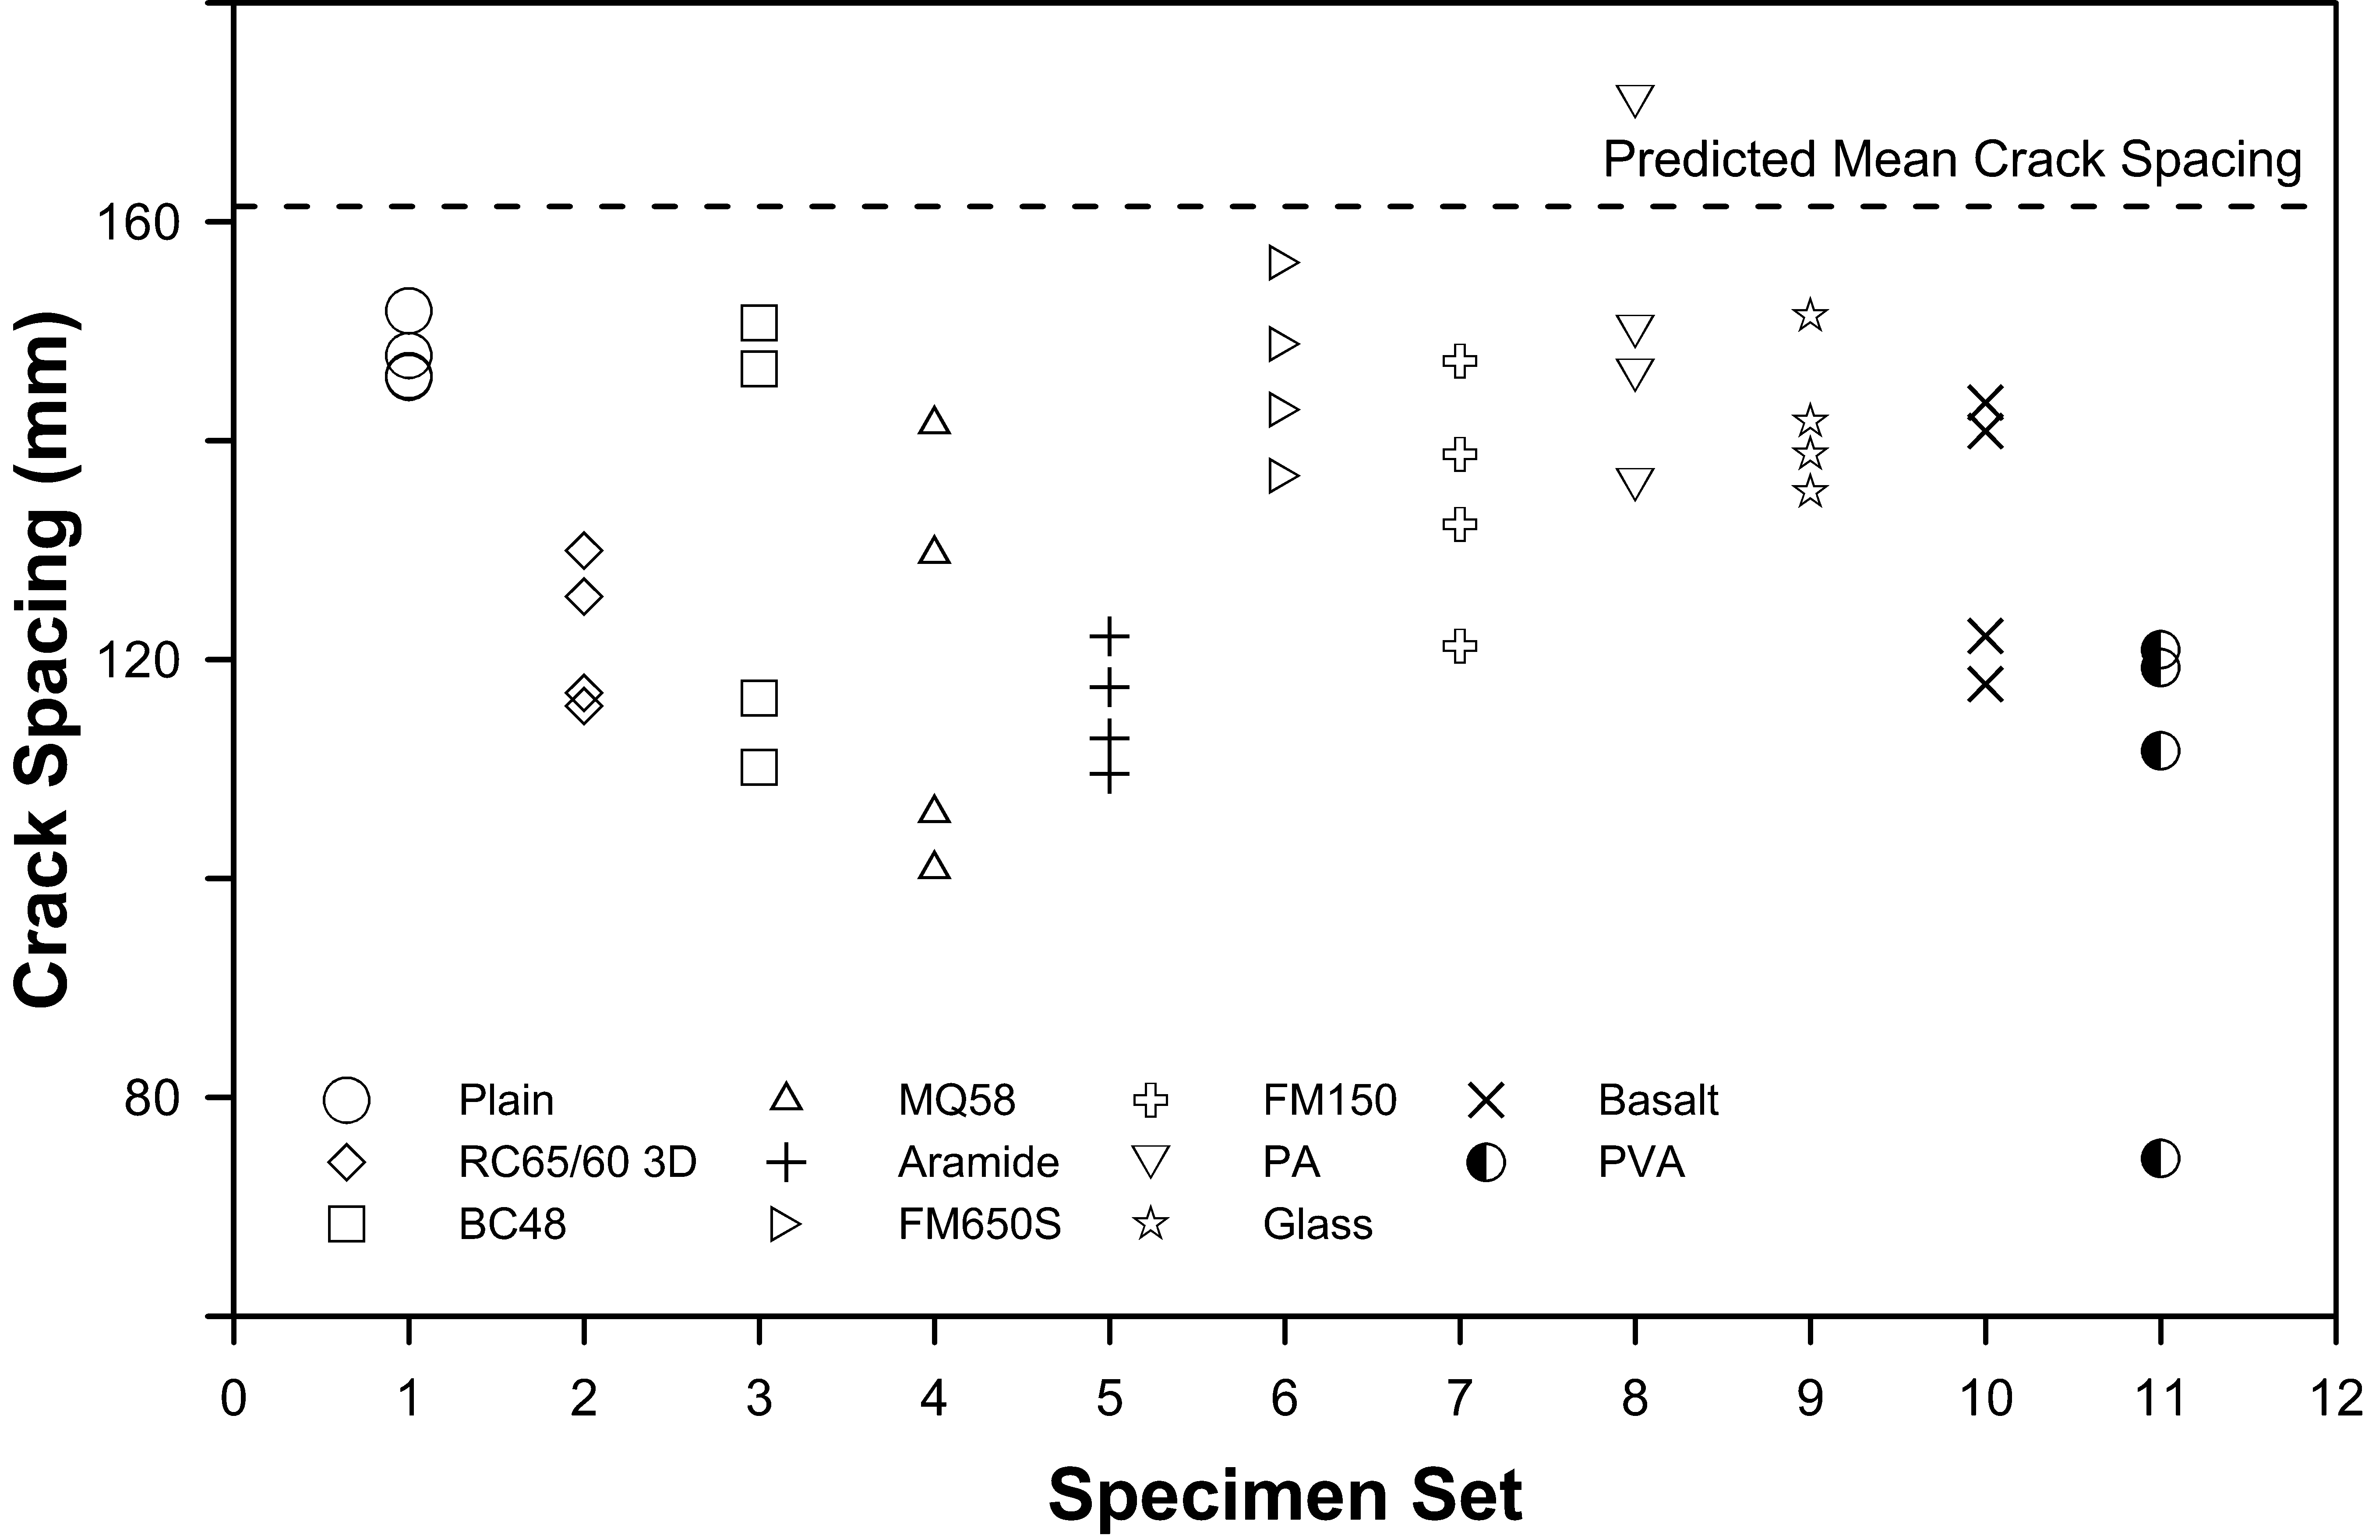
Figure 4: Mean crack spacing results for all beam specimen sets at 70 kN service load (50% of ultimate load), compared to predicted mean crack spacing for plain concrete.
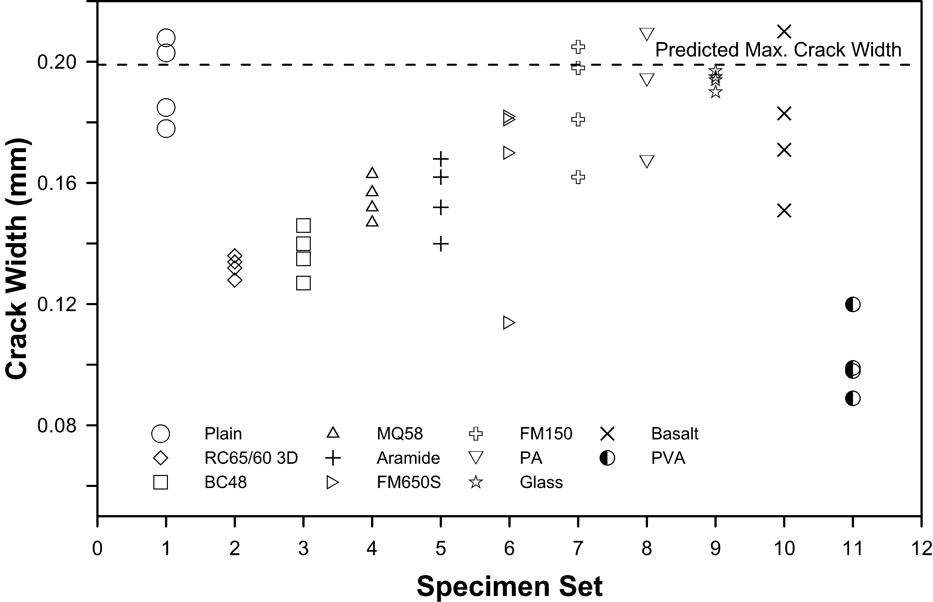
Figure 5: Mean crack width results for all beam specimen sets at 70 kN service load (50% of ultimate load), compared to predicted max crack width for plain concrete.
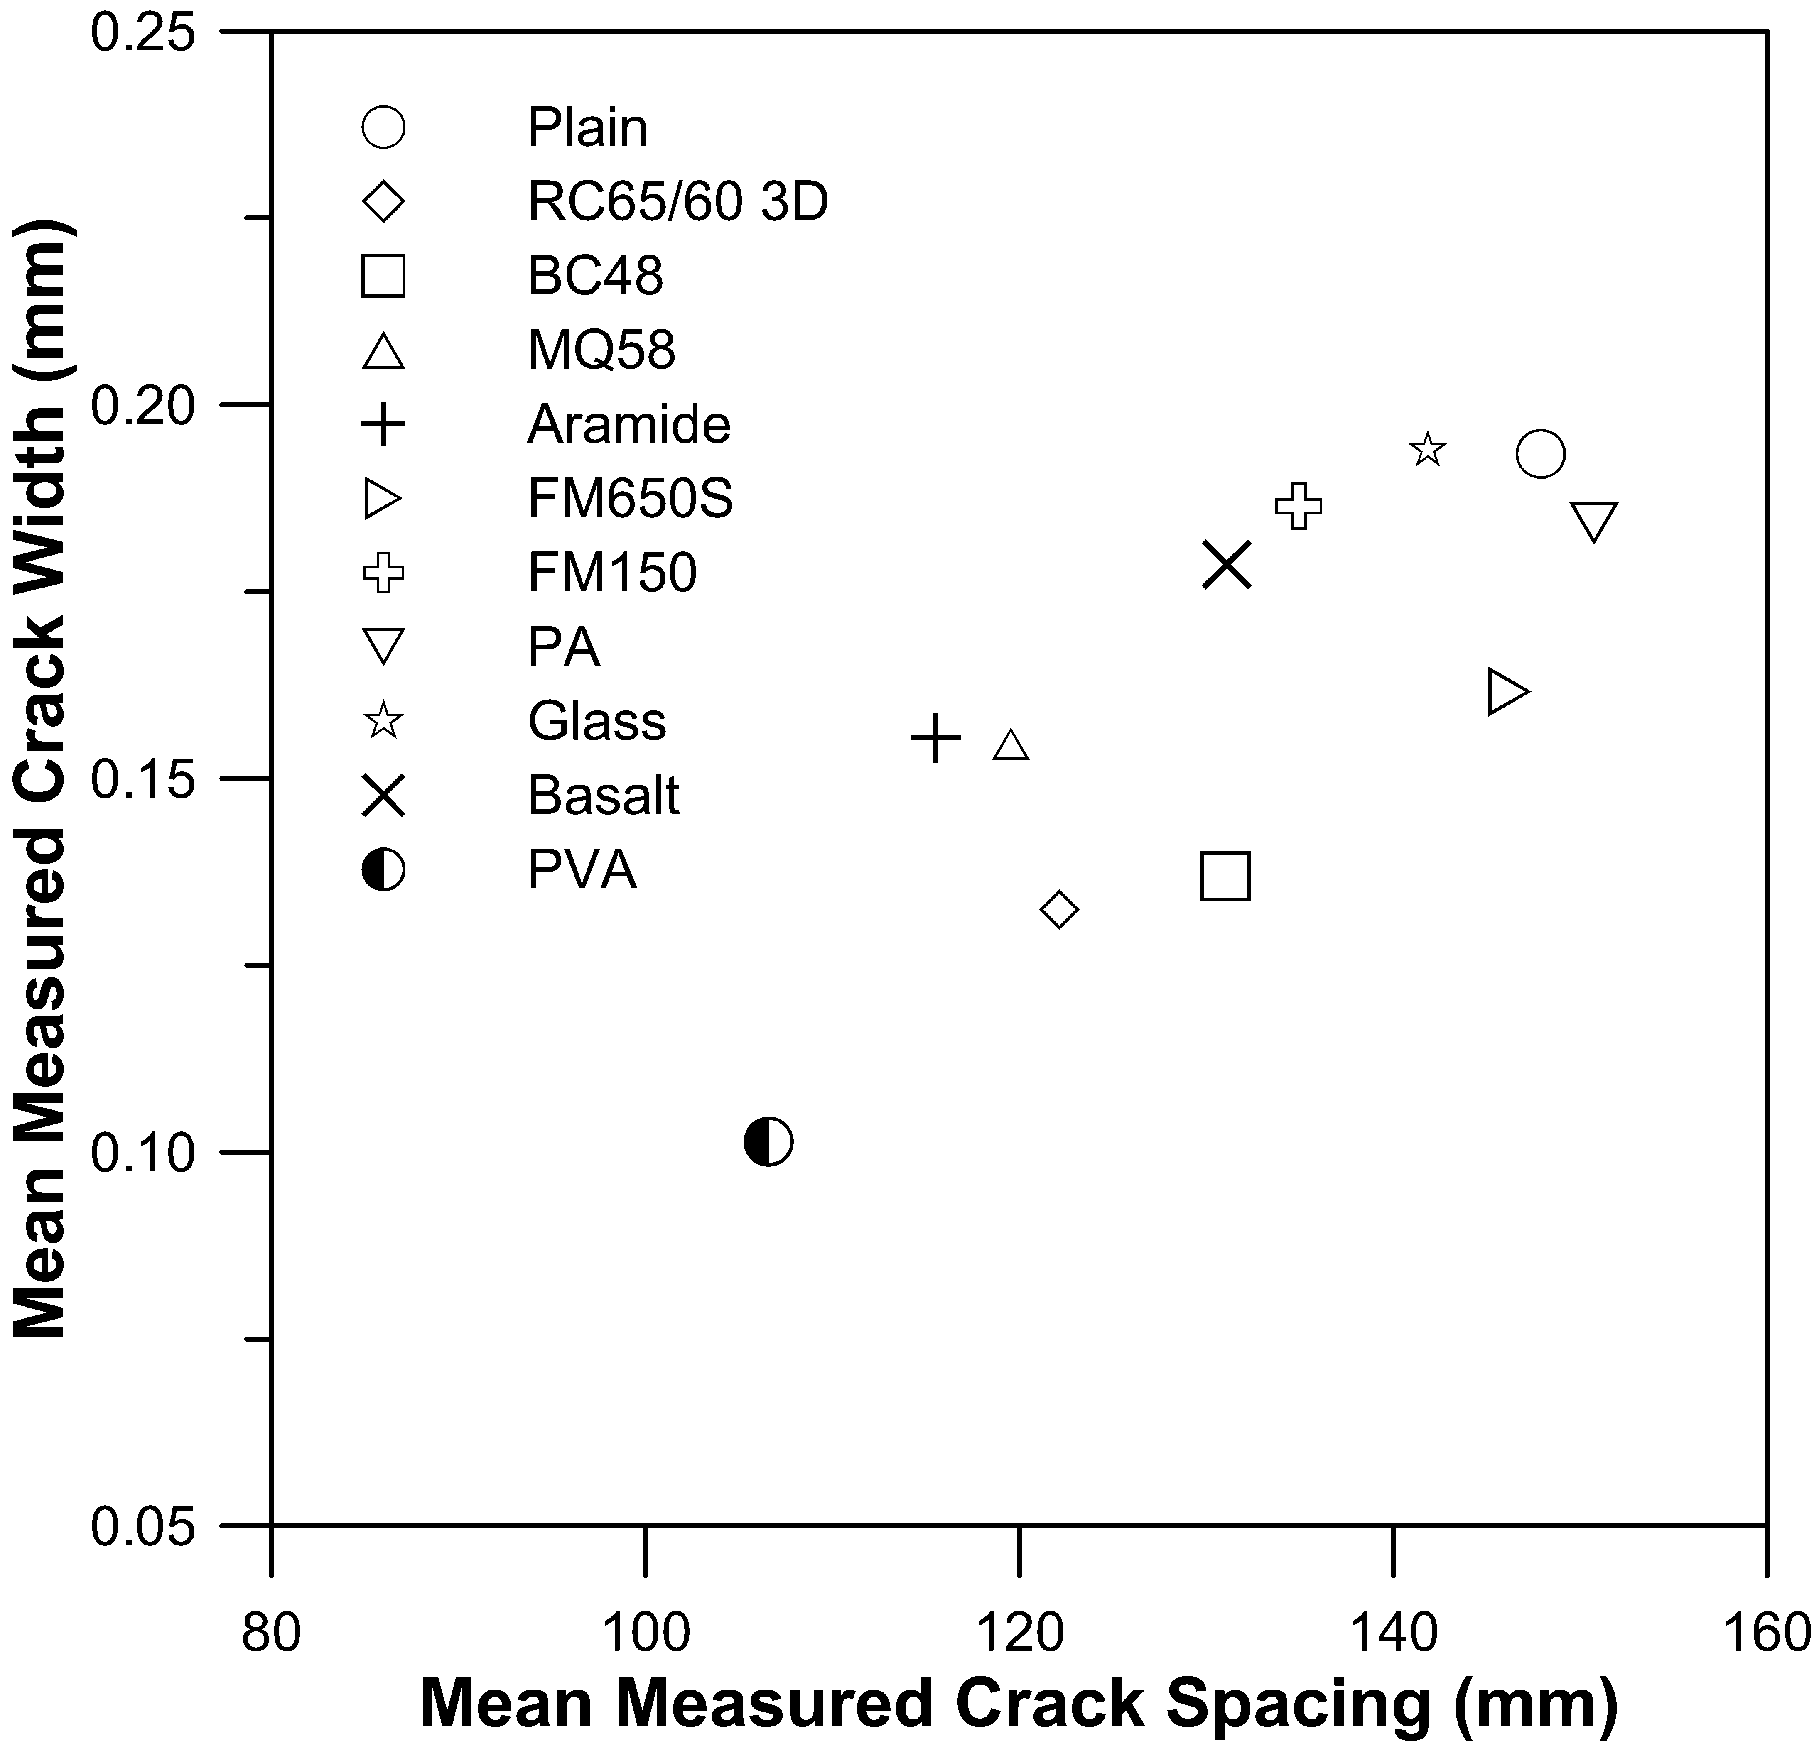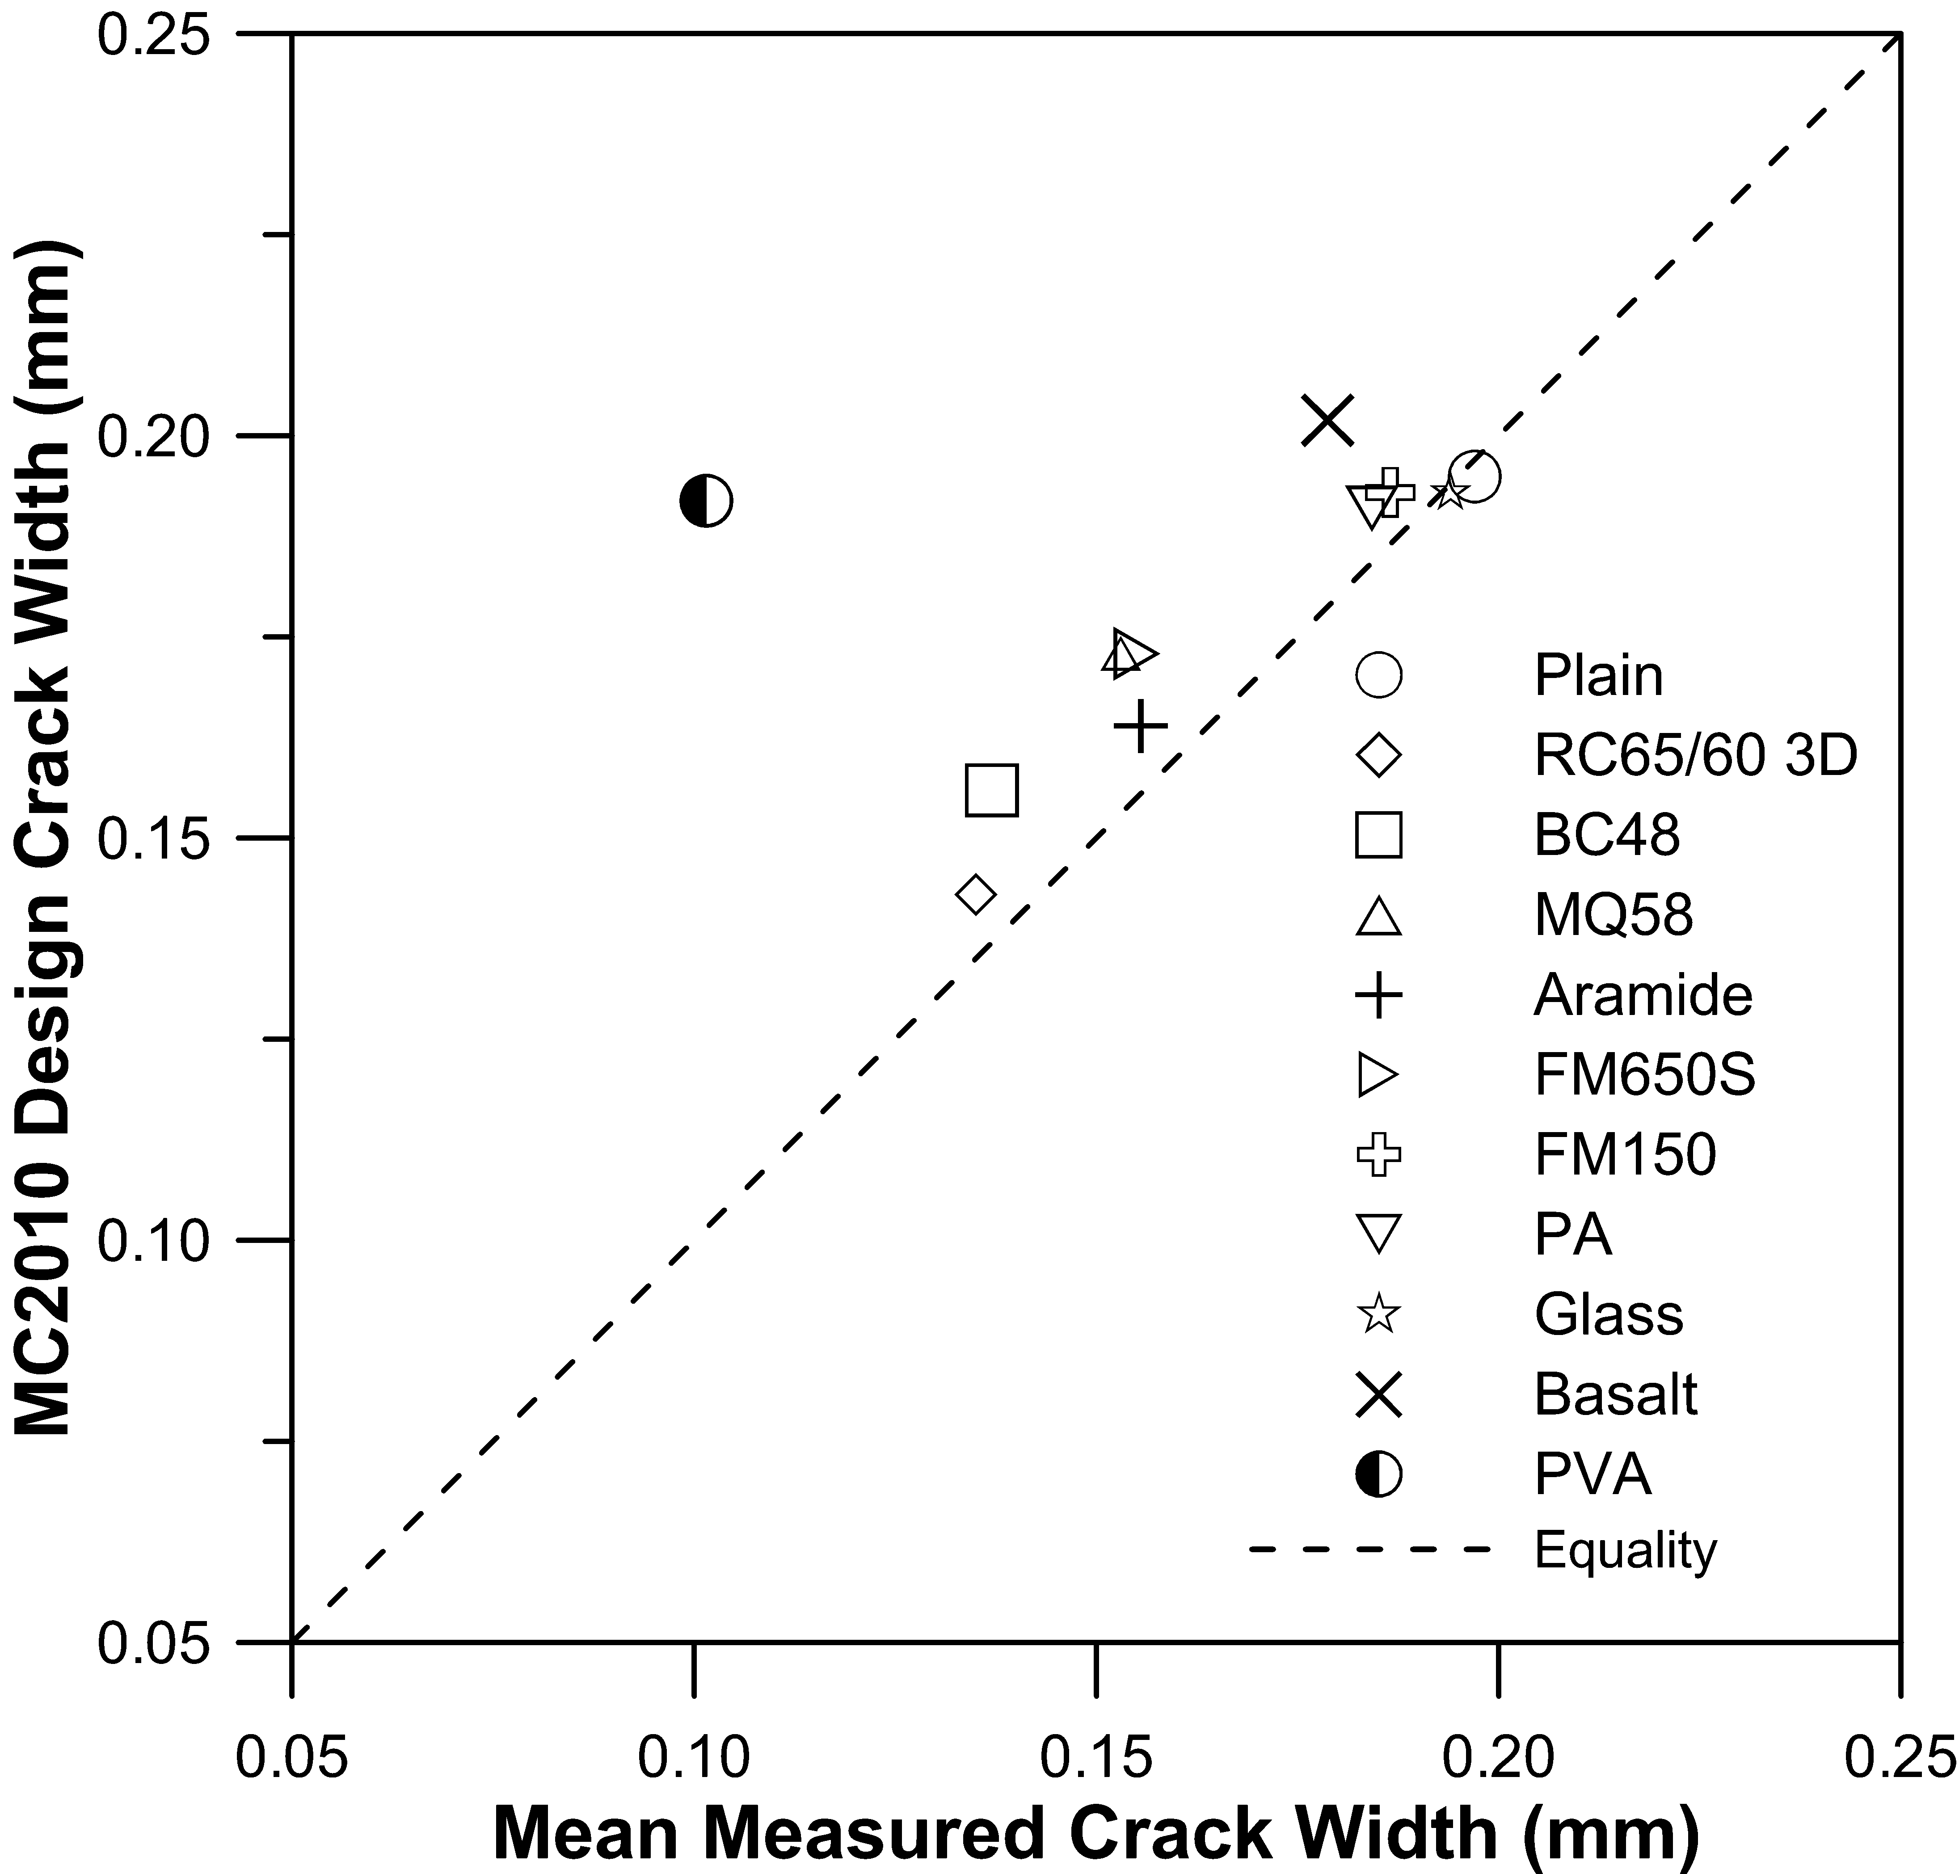
(a) | (b)
Figure 6: (a) Relationship between measured crack spacing and width for all beam specimen sets at 70 kN service load (50% of ultimate load), and (b) comparison of measured mean crack width at 70 kN load and predicted design crack width (based on ASTM C1609 beam results).
The stand-out performer in terms of both crack spacing and crack width reduction was the PVA micro-fibre. Although the spread in mean crack spacing results was high (Fig. 4), the mean crack width was reduced consistently across all four specimens and was equivalent to a 48% reduction in crack width compared to the plain concrete control for the addition of only 4 kg/m³ of fibre (Fig. 5). Moreover, this dosage rate of fibre proved quite workable when 500 mL/m³ of PCE superplasticizer was included.

Analysis
The mean measured crack width has been plotted against mean measured crack spacing at 50% of ultimate load in Fig. 6a to reveal a roughly linear relationship between the two parameters for the 11 specimen sets presently tested. The PVA fibre set resulted in measured crack width and spacing that were significantly lower than measured in any other set, but the relationship between these two parameters still appeared to conform to the same trend obtained for the other ten data sets.
The mean crack spacing was determined using the method described in Eurocode 2 (2004) and reproduced in AS3600. Based on the plain concrete section properties, the mean crack spacing was found to be 161.4 mm, which compares well with the measured mean crack spacing (Fig. 4). However, the predicted maximum crack spacing, normally taken as 70% larger than this, appears to be excessive at 230 mm. The predicted maximum crack width for the plain RC section based on Eurocode 2 was 0.199 mm, which compares well to the mean crack widths measured in the specimens (Fig. 5).
An attempt was made to compare the measured mean crack width for each set with predictions of design crack width based on the method described in Model Code 2010. However, the Model Code uses data on post-crack performance for FRC derived from EN14651 beam tests, whereas ASTM C1609/
C1609M beam tests were used in the current investigation. The predictions for w_{d} using Eq. 7.7-12 in the Model Code have therefore been made using estimates of f_{Ftsm} in Eq. 5.6-5 based on the residual strength at 0.75 mm central deflection in ASTM C1609/C1609M rather than f_{R1} from EN14651 (see Table 2 for beam test results). From the Model Code, Eq. 7.7-22 is reproduced as
(1)
in which f_{Ftsm} has presently been taken as equal to 0.45 times the residual strength at 0.75 mm central deflection in ASTM C1609 beams; σ_{s} is the calculated stress in the steel based on a concrete section with (or without) fibres, σ_{sr} is the maximum stress in the steel (based on Eq. 7.6-6), and η_{r} is taken as zero (Table 7.6-2). The resulting predictions of w_{d} are slightly greater than the measured mean crack widths (see Fig. 6b) for all the mixes other than the PVA mix. The PVA mixture resulted in measured crack widths that were about half the predicted estimate, suggesting that PVA micro-fibres behave in a manner that is different from the other investigated fibres. It is interesting to note that the ASTM C1609 beams revealed load-deflection performance for the PVA fibre reinforced mixture that was far inferior to that evident for the steel and macro-synthetic FRC mixtures at 0.75 mm (Fig. 2b), yet the PVA mixture performed much better than any of the other mixtures. This could possibly have arisen because the PVA micro-fibre is very small and highly dispersed, which increased the likelihood that a fibre would intercept a micro-crack at the formation stage, thereby controlling growth. In contrast, the steel and macro-synthetic fibres were large and widely spaced, reducing the likelihood that they intersected a crack as it formed. Of the other data sets, the aramide fibre mixture appeared to result in crack widths that were somewhat larger than the trend evident in the majority of mixtures.
Note that almost all the FRC mixtures exhibited a higher residual strength in the range of 0.1-0.3 mm crack width than was evident at 0.75 mm central deflection (which corresponds to about 1.0 mm maximum crack width). It should be noted that the only parameters that varied between the 11 sets in the section analysis described in MC2010 were the compressive strength of the concrete (used to predict f_{ctm}) and the post-crack performance of the FRC (Table 2). The cracks were taken to lie in the stabilized cracking stage. The stress in the steel was taken to be that occurring for a plain or FRC concrete section with 3×16 mm bars.
If post-crack performance at a smaller crack width in the ASTM C1609 beams is used as the design parameter, then the predicted design crack width would have been larger for almost all the mixtures. This would have resulted in the trend line in Fig. 6b lying a little closer to equality for all the mixtures, and much closer for the PVA mix. This suggests that using a prediction method based on empirical data generated at 0.5-1.0 mm maximum crack width may not produce good estimates of in-service crack widths for FRC comprised of fibres that display rapid changes in performance in the immediate post-crack range.

Concluding remarks
A series of trials were undertaken in which large Reinforced Concrete beams were cast and tested using plain concrete and Fibre Reinforced Concrete to examine the effect of the addition of steel and synthetic fibres on flexural crack widths. The beams were loaded in four-point bending, and crack spacing and widths were measured for increasing applied moment. The results demonstrated that fibres can reduce both the spacing and width of cracks when used in combination with conventional steel reinforcement.
Steel and macro-synthetic fibres made of polypropylene and aramide were found to substantially reduce flexural crack widths, and that the degree of crack width reduction was related to post-crack residual strength. The majority of micro-synthetic fibres, made from polypropylene, glass, and basalt, proved ineffective in reducing either crack spacing or width. However, PVA micro-fibres were found to be highly effective in reducing both crack spacing and width, and the efficacy of these fibres was much better than is suggested by the post-crack performance exhibited in standard beam tests. It is therefore apparent that some synthetic fibres are very effective for crack width control and deserve to be investigated in further detail for their potential use in reducing flexural crack widths in RC/FRC hybrid members.

Acknowledgements
The Author acknowledges the support provided by EPC Pty Ltd in funding this work, and Joshua Tolhurst and Keith Clarke in conducting the majority of the tests described in this paper.

References

Abrishami, H. H., and Mitchell, D., 1997. “Influence of Steel Fibres on Tension Stiffening,” ACI Structural Journal, 94(6) pp769-776.

AS/NZS 4671: 2001 Steel Reinforcing Materials, Standards Australia, Sydney.

Australian Standard AS3600, 2014. Concrete Structures, Standards Australia, Sydney.

Australian Standard AS3600, 2014 Concrete Structures, Commentary, Standards Australia, Sydney

Bernard, E.S., 2016. “Investigation of Crack Width Control Using Barchip Macro-synthetic Fibres in Reinforced Concrete Beams”, World Tunneling Congress 2016, San Francisco, April 22-28.

Bischoff, P. H., 2003. “Tension Stiffening and Cracking of Steel Fibre-Reinforced Concrete,” Journal of Materials in Civil Engineering, ASCE, 15(2), pp. 174-182 doi: 10.1061/(ASCE)0899-1561(2003)15:2(174)

Conforti, A., Zerbino, R., and Plizzari, G.A., 2018. “Influence of steel, glass and polymer fibers on the cracking behavior of reinforced concrete beams under flexure”, Structural Concrete, 1-11. doi: 10.1002/suco.201800079

Deluce, J.R., Lee, S-C., and Vecchio, F.J. 2014, “Crack Model for Steel Fibre-Reinforced Concrete Members Containing Conventional Reinforcement”, ACI Structural Journal, 111(1) pp93-102. doi: 10.14359/51686433

Dupont, D., and Vandewalle, L., 2003, “Calculation of Crack Widths with the σ-ε Method,” Test and Design Methods for Steel Fibre Reinforced Concrete: Background and Experiences, Proceedings of the RILEM TC162-TDF Workshop, RILEM Technical Committee 162-TDF, Bochum, Germany, pp119-144.

Eurocode 2, 2004. Design of Concrete Structures, British Standard BS EN 1992-1-1:2004, European Committee for Standardisation (CEN).

fib, 2012. Model Code 2010, Bulletin 65, Fèdération Internationale du Béton, Lausanne

Gilbert R.I. and Bernard, E.S., 2015. “Time-dependent Analysis of Macro-synthetic FRC Sections with Bar Reinforcement”, World Tunneling Congress 2015, Dubrovnik, May 22-28.

Gilbert R.I., Mickleborough, N.C. and Ranzi, G., 2017. Design of prestressed concrete to Eurocode 2, Second Edition, CRC Press (Spon Press), Florida.

Jansson, A., Gylltoft, K., and Löfgren, I, 2010. “Flexural behaviour of members with a combination of steel fibres and conventional reinforcement”, Nordic Concrete Research, (42) pp155–171.

Tiberti, G., Minelli, F., Plizzari, G.A., and Vecchio, F.J., 2014. “Influence of concrete strength on crack development in SFRC members”, Cement & Concrete Composites, 45, pp176-185. doi: 10.1016/j.cemconcomp.2013.10.004

Vandewalle, L., 2000. “Cracking behaviour of concrete beams reinforced with a combination of ordinary reinforcement and steel fibres”, Materials and Structures, 33, pp164-170. doi: 10.1007/BF02479410

